# Micro:pet cheat sheet

These solutions will work with both V1 and V2 micro:bits and V2 code blocks are indicated in the title with (V2)

## Smiley face for the micro:pet

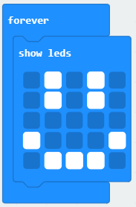

## Reacting to playing/shaking (accelerometer)

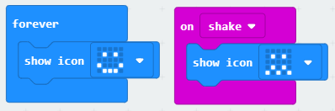

## Reacting to playing/shaking (accelerometer) (V2)

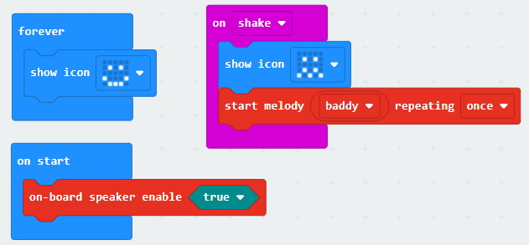

## Emotions that are effected by interaction

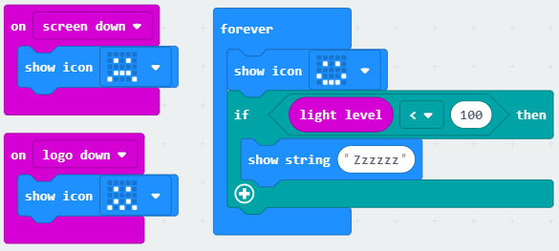

Wakes up when it hears a loud noise (V2)

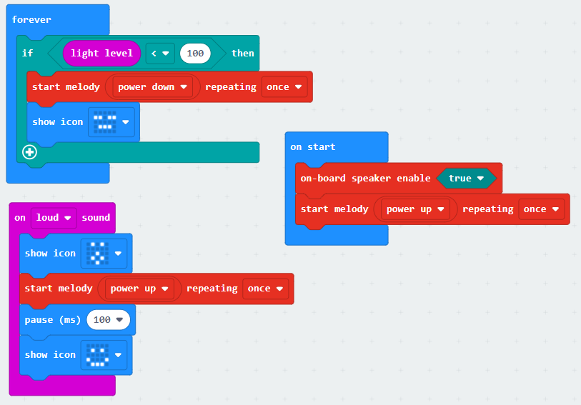

## Feeding (every few seconds/minutes)

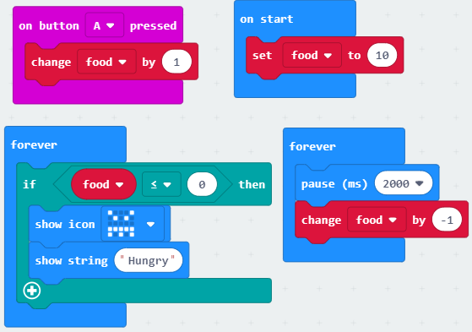

Feeding (every few seconds/minutes) (V2)

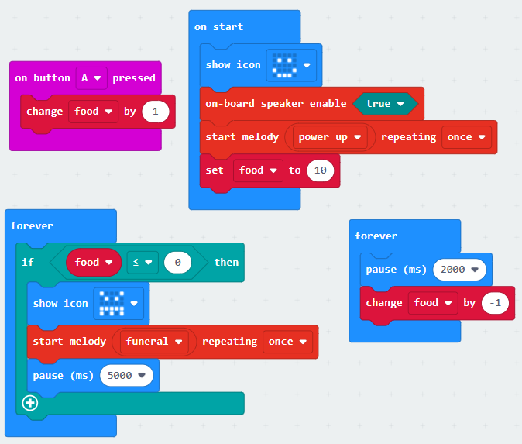

## Needing attention (gets lonely if not interacted with frequently)

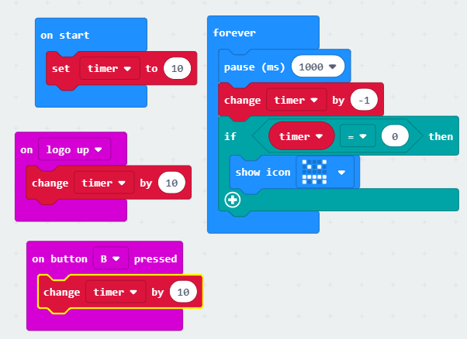

## Sleeping and waking (light sensor)



## Reacting to temperature (temperature sensor)

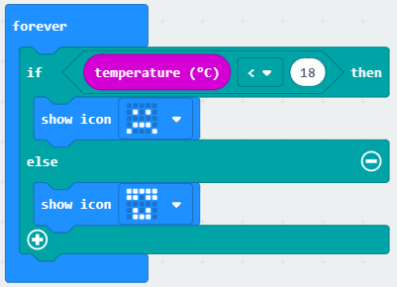

## Communication/interaction between micro:pets (advanced)

|  |  |
| --- | --- |
| Micro:pet 1 | Micro:pet 2 |
|  |  |